**Fr. Conceicao Rodrigues College of Engineering**

**Bandra**

**Computer Department**

**SEM-V**



**Web Technology Project**

**Group Members:**

Karishma Potdukhe (8628)

Ganesh Reddy(8631)

Sanath K Shetty(8640)

**Guide:** Mr. Mahendra Mehra

**TABLE OF CONTENTS**

1. Introduction -----------------------------------------------------------------------------------3
2. Purpose-----------------------------------------------------------------------------------------3
3. Technology Stack-----------------------------------------------------------------------------3

4.   Process-------------------------------------------------------------------------------------------4

5.  Non-functional Requirements

6.1 Safety and Security-------------------------------------------------------------------------4

6.2 Software Quality Attributes---------------------------------------------------------------4

6. Future Aspect------------------------------------------------------------------------------------5

7. System Outlook----------------------------------------------------------------------------------5

8. Conclusion---------------------------------------------------------------------------------------10

9. References---------------------------------------------------------------------------------------10

**INTRODUCTION**

In this ever-growing age of technology, Online quizzes are a popular form of entertainment for web surfers. Online quizzes are generally free to play and for entertainment purposes only , though some online quiz websites offer prizes. It is one of the most common eLearning patterns for many of the online course. Many online quizzes are set up to actually test knowledge or identify a person's attributes. Some companies use online quizzes as an efficient way of testing a potential hire's knowledge without that candidate needing to travel.

**PURPOSE**

The purpose of this document is to describe the requirements for Online Quiz Management System. The project includes quizzes about various topics. In this system, we can keep a track of leaderboard scores . The quiz has a set of timer and also ensures large number of participation and randomization of questions.

**TECHNOLOGY STACK**

**Front End:**

* HTML5
* CSS3
* Bootstrap
* jQuery
* Embedded JavaScript

**Server End:**

* NodeJS
* Express
* MySql

**PROCESS**

To start the quiz, the participant needs to be logged in.

If he/she is a first-time user, then he/she needs to register.

After registration, the details of the participant i.e firstname, lastname, username and password get saved in the database.

After entering the credentials, the participant is shown a list of choices (ex: sports, general knowledge etc) from which he has to choose.

Upon selecting the category, the quiz starts and a timer of 5 mins is set.

Once the quiz is completed, the number of correct and incorrect answers is displayed along with the participant’s score. After completion of quiz, the participant gets to know his marked answer and the correct answer.

The project also maintains a leader board which shows the names and current scores of the leading competitors.

**NON-FUNCTIONAL REQUIREMENTS**

**Safety and Security Requirements**

* **Login ID:** Any participant who uses the system shall have a Login ID and Password.
* **Security:** Security is the prime and the utmost importance of the system and we made sure that data stored doesn’t get leaked or hacked and at the same time it is not accessible by all as well.

**Software Quality Attributes**

**Maintainability---**

* **Availability:** The system shall be available all the time.
* **Network Connection**: The participant should be connected to internet 24 X 7.

**FUTURE ASPECT**

The pandemic has forced the global academic community to explore new ways of learning and teaching, including distance and online education. Our project can be used to make e-learning possible. It engages the audience in a unique and fun way and connect them to brand or learning material.  Besides the advantage of time saving, it also helps preventing students from [cheating](https://www.onlinequizcreator.com/knowledge-center/exam-knowledge-center/how-to-prevent-cheating-on-an-online-exams-and-tests/item10616). Our Online Quiz Management System also gives the participant plenty of room for knowledge retention.

**SYSTEM OUTLOOK**

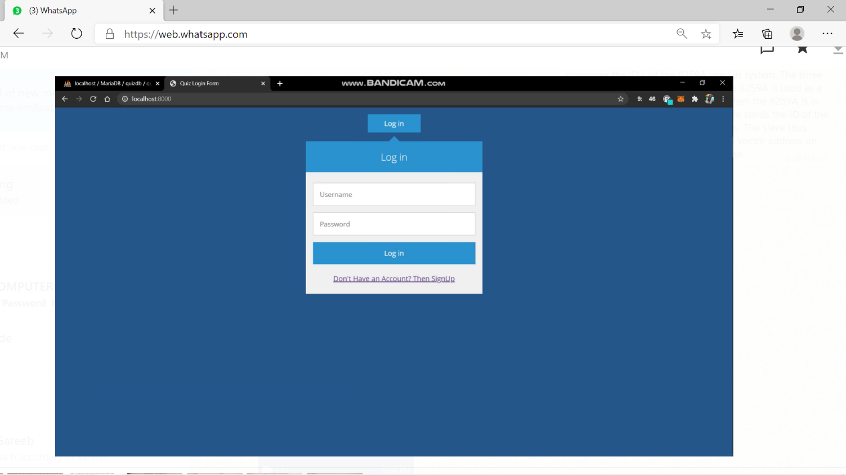

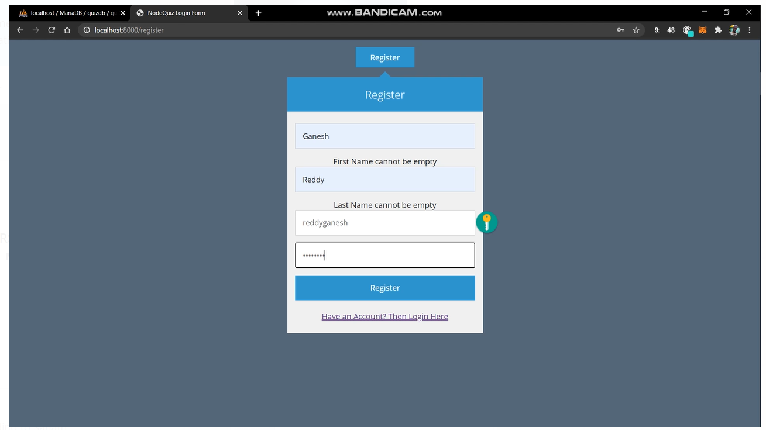

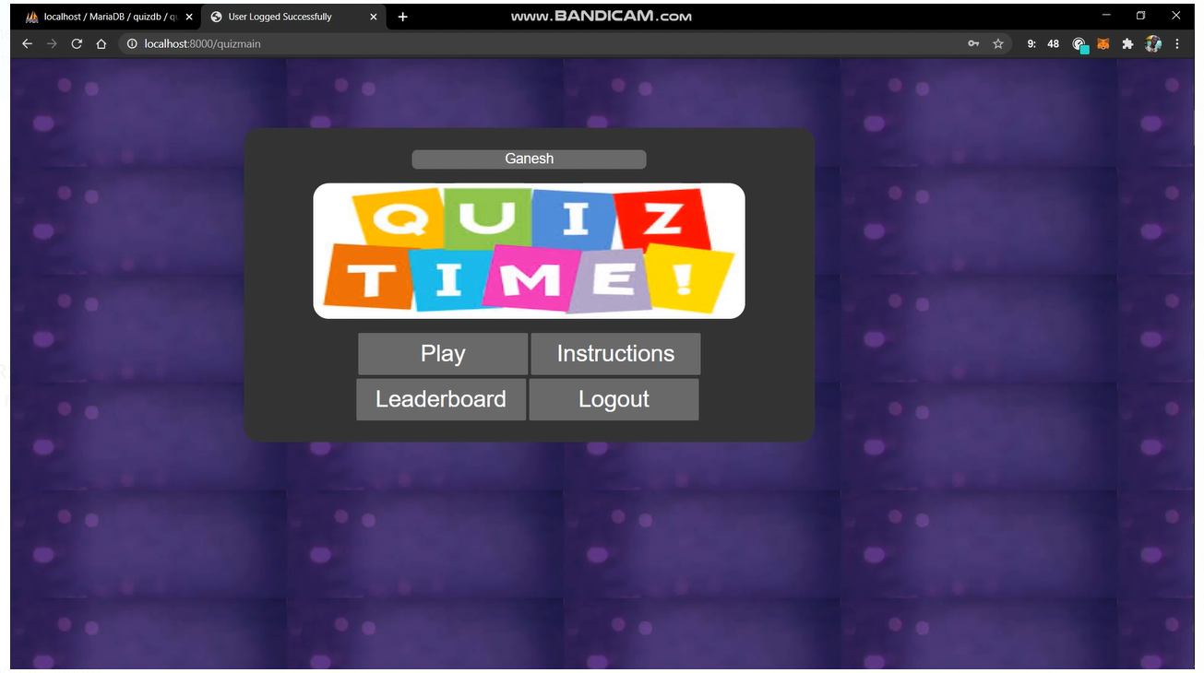

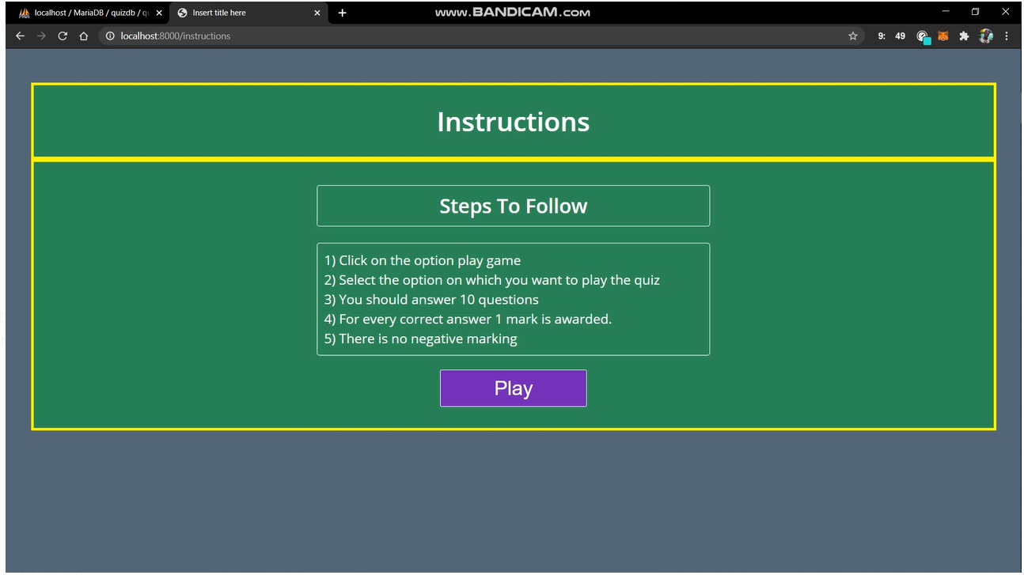

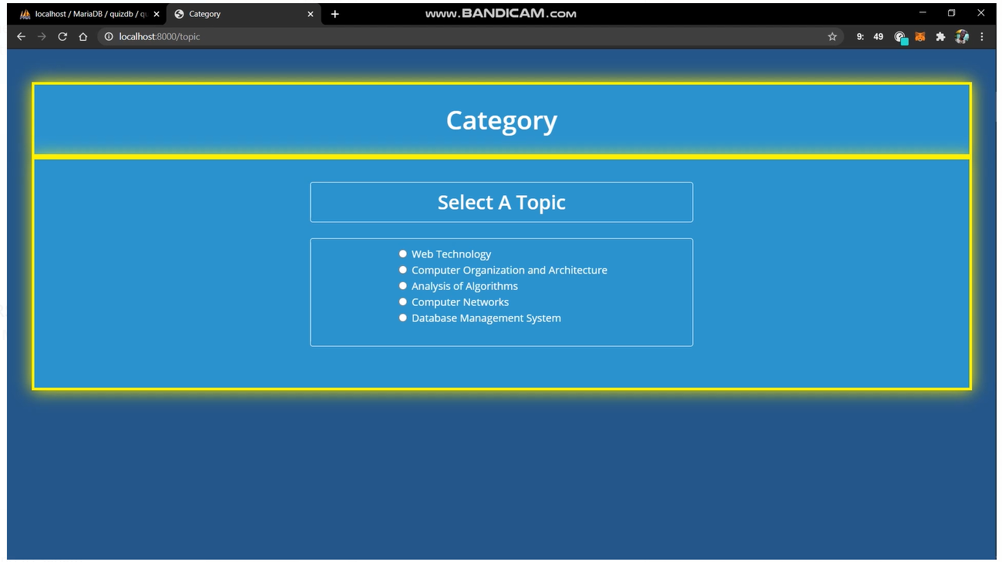

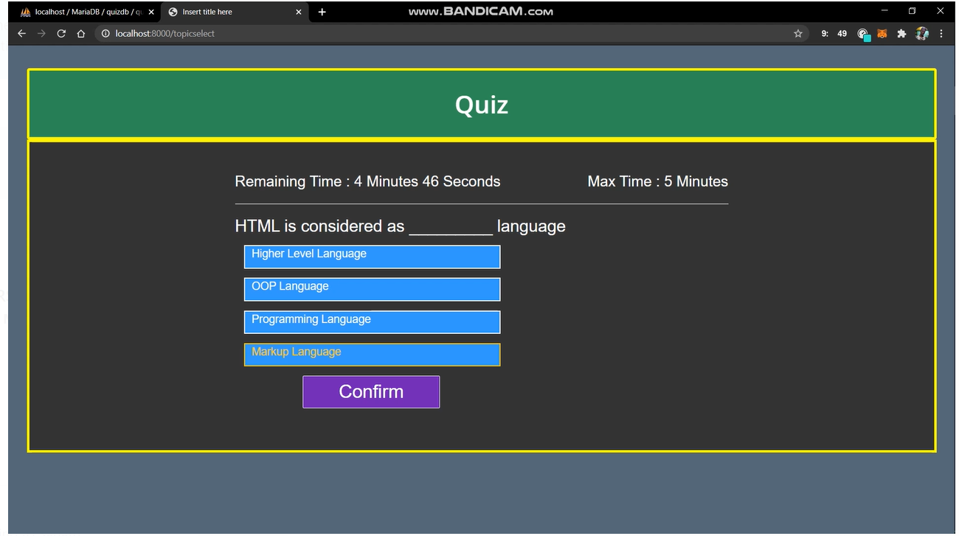

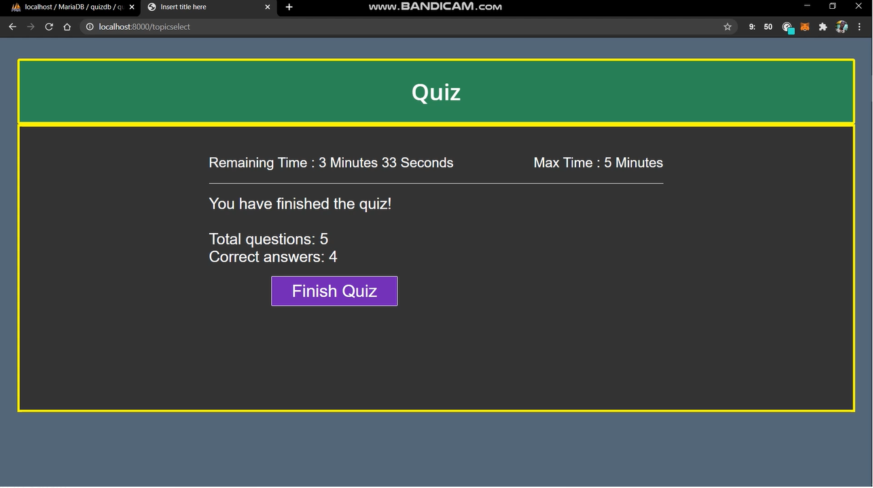

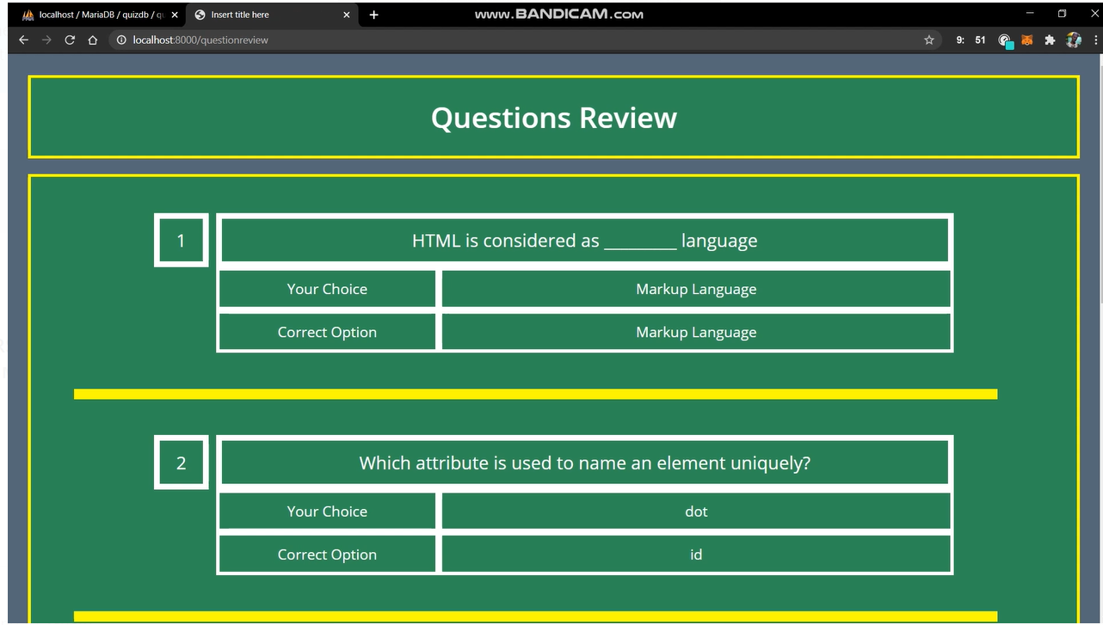

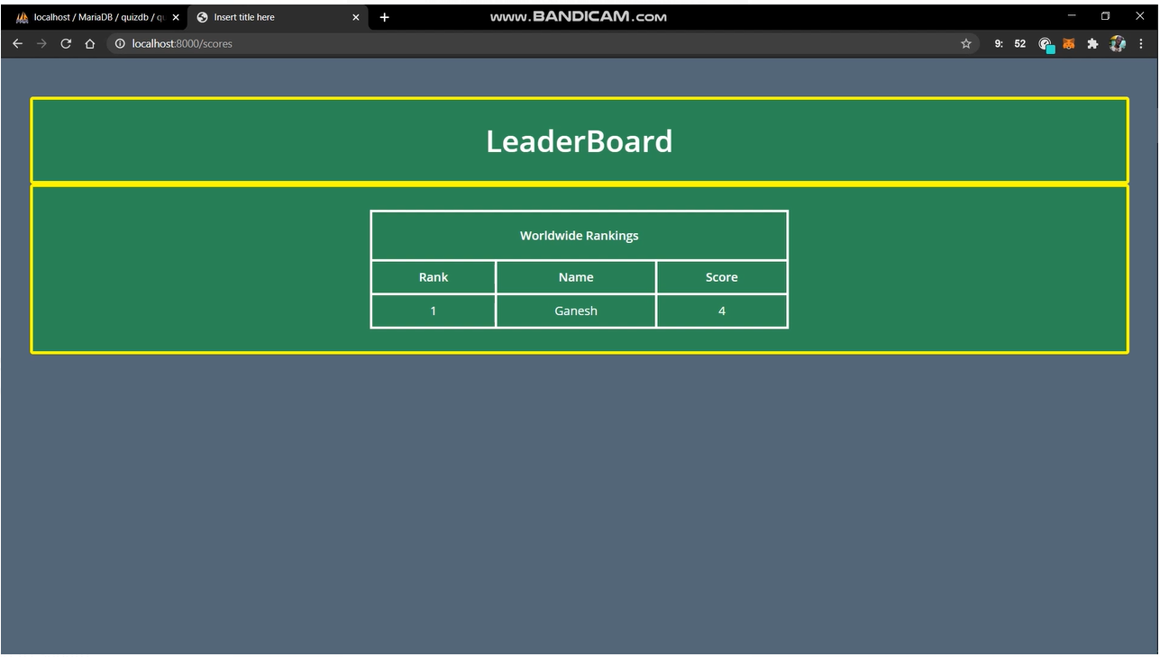

**CONCLUSION**

To conclude, this online quiz system provides facility to conduct online examination world-wide. It saves time as it allows number of participants to give the quiz at a time and displays the score as the test gets over. It is automatically generated by the server. Participant can register, login and give the test with his specific username, and can see the scores and leader-board as well.

**REFERENCES**

<https://www.javatpoint.com>

<https://www.t4tutorials.com>

https://www.slideshare.net